Balloons Project – System Architecture

Andrew Dodd

# Introduction

This document gives an overview of the entire Balloons Project system along with a brief description of its main components. Further details on each individual system can be found in the corresponding section of documentation.

# System Overview

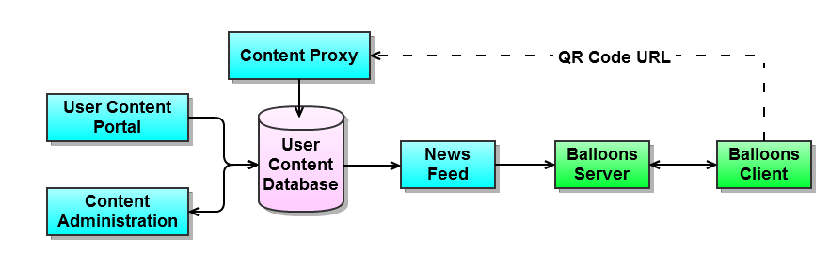

Items in light blue are web-based components, written in PHP and producing either HTML/JS/CSS page output or JSON objects. Green items are written in C# 4.0 and the pink database is an SQL RDBMS. The QR Code URL is accessed by users when viewing content and is usually interpreted by a third-party device such as a mobile phone.

## Web-Front Ends: User Content Portal & Content Administration

Two web-based front ends exist. The User Content Portal is used by users to submit custom content which will appear as a balloon on the system. Once content is submitted it is stored in the User Content Database. The Content Administration section lets administrators review and moderate any user generated content and will be primarily used to remove offensive or otherwise inappropriate content.

## Content Proxy

The content proxy is used to provide an interface for end users to rate content by either giving it an up or down vote. Once the vote is cast, it is stored against the story in the database and the user is redirected to the URL of the content.

## News Feed

The News Feed component is responsible for choosing some content for the front-end; ratios for the different content-types are defined in the feed whilst the number of items to fetch is determined by the caller. When requested, it generates a JSON object which is consumed by the Balloons Server.

## Balloon Server

## Balloon Client